

Index

User`s Manual 2
Main Menu 2
Client Search 3
Client Detail 4
Client Contract 8
Invoices 10
Weekly Schedule by Location 12
Presence Sheet 13
The Presence Card 15
Administration 18
Company 19
Static Lists 19
Courses 22
Add Courses 23
Courses Edition 24
Schedule Units (Event) 24
Retired Courses 25
Ordering the List 26
Contracts 27
Invoices 29
List of Contracts 30
List of Invoice 32
Finances 32
Real Income 33
Income perceived in advance (IPA) 34
Address List 35
Client List 36
Emails 38
Follow up Alerts 39
Payments List 41
User's List 42
Add User 42
User Modification 43
Style Modification 43
Configuration 43
Business Logic 43
Add Status 43
Modify Status 43
Automatic Status Modification 44

User`s Manual

Argotik is an Web 2.0 application for enterprises who manages events like courses, conferences and reservations. The software is delivered over the Internet.

This user manual is intended to help the users of the Argotik with the many features and functionalities it provides. Other documents are available explaining the inside design, the data schema and the technical specifications. They are available on HTUhttp://www.argotik.netUTH.

Argotik`s functionalities extends from customer management, contracts, invoices, reservations and presence. Its weekly schedule, on the spot configuration and multiples financial reports, customers follow up and bulk email sending makes it an intuitive, easy to use fast and helpful business tool.

Argotik know how to deal with concept of regular and unlimited characteristics of courses as events.

The notion of invited client allows entering reservations or rendezvous for clients even without a contract.

Main Menu

Each screen will show on the top line the same few links to access the main feature of the application. These features are

New: to add a new client
Clients: to access a specific client
Weekly Schedule: to access the courses schedules
Administration: to access configuration features and reports
Log off: to quite the application

Other main feature like Contracts, Invoices, Client`s Presence Card, Client Calendars and Presence Sheet are accessible through many links shown on other screens like the Weekly Schedule or the Reports.

The menu items are not all available to every user. It depends on the User Type. There are three defaults User Type:

Supervisor who have access to every feature of the application;
Administrator who has access to all feature but the User List module;
User who has a restricted access to basic function (no access to the Administration module).

It is possible to change the restrictions for these types of users or even to create new type of user but this must be must be done by technical support.

The default screen showing up is Client Search

Client Search

This is the convenient screen to access to a client record by different criteria. The whole list of client is directly available trough the Clients. Other fields allow getting a sub list of corresponding clients from which to pick the right one.

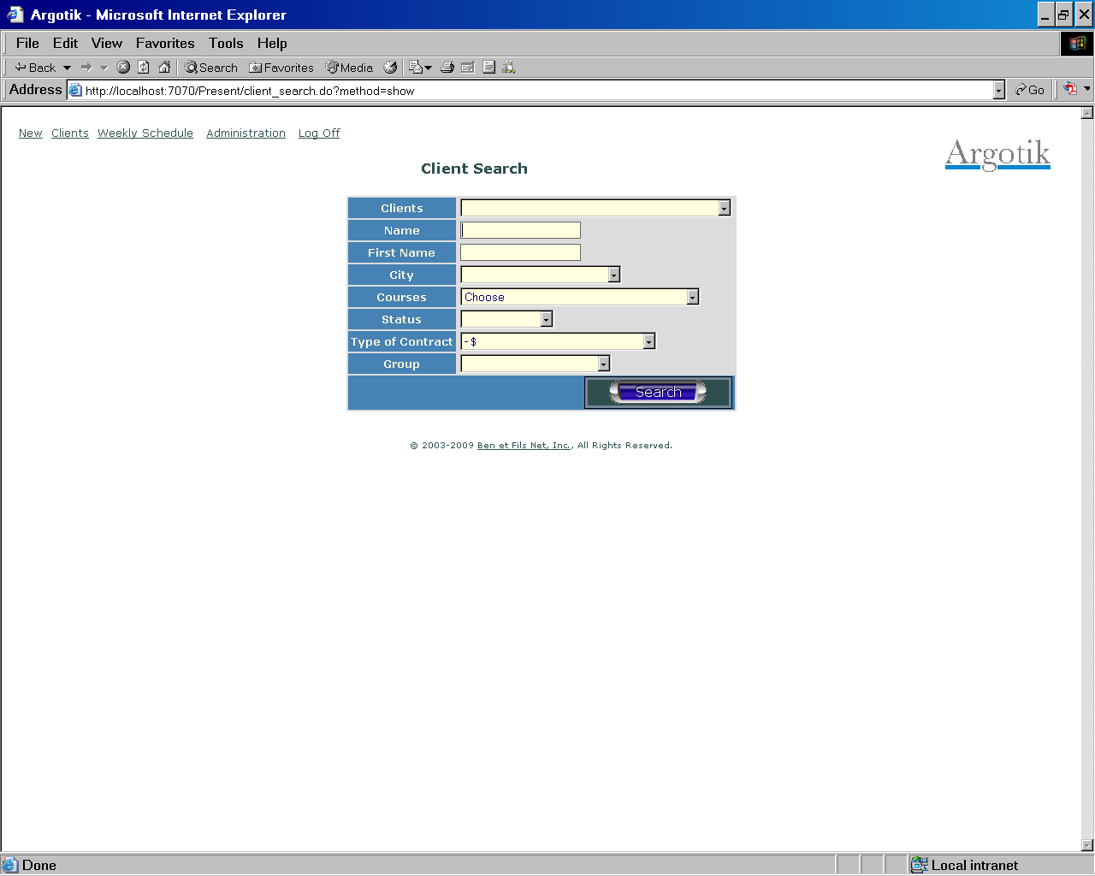

One can simply fill only one letter in the «Name» to get the list of all clients beginning with that letter. The search is case insensitive.

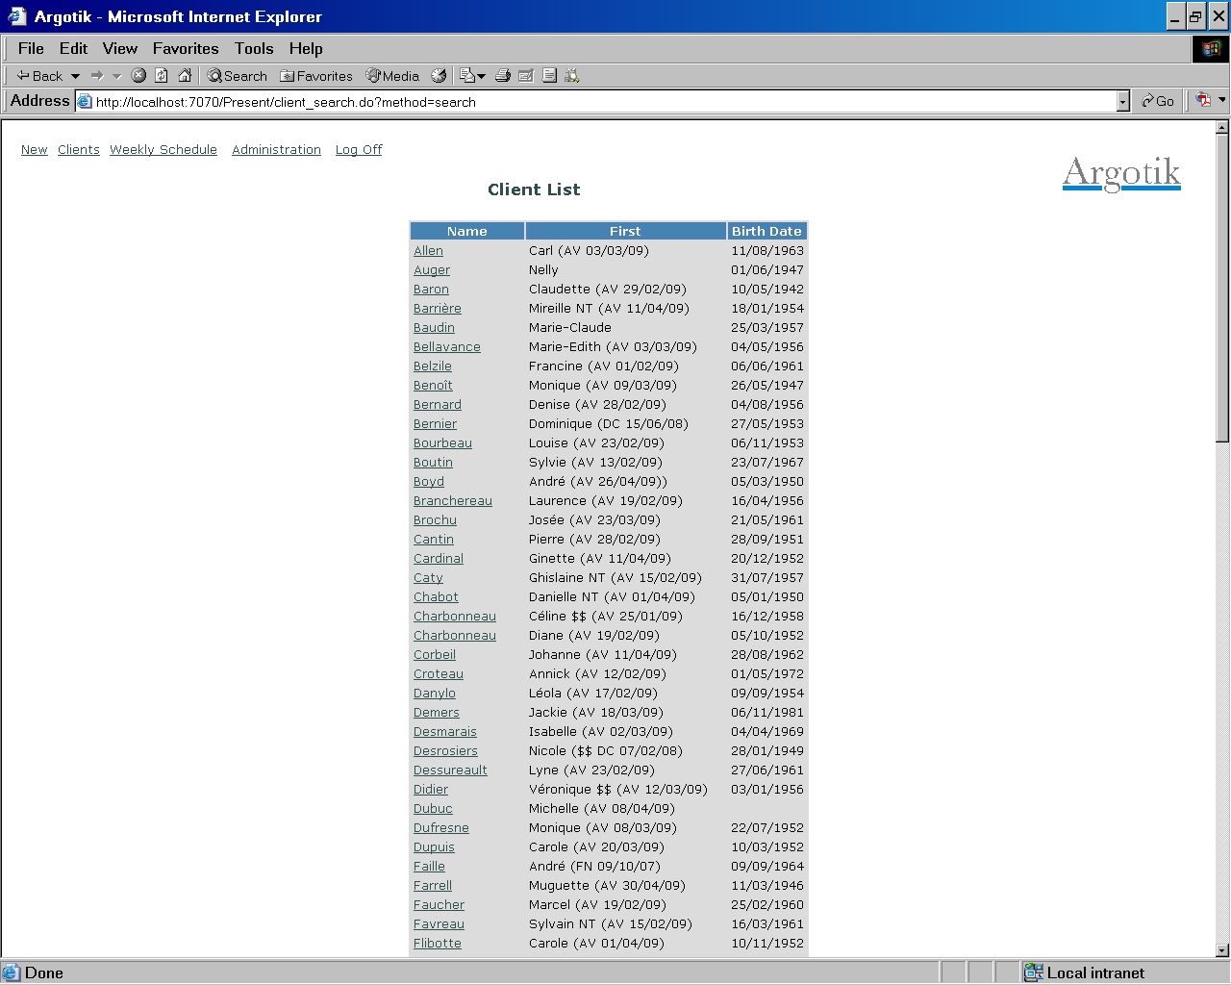

If the result resume to only one client, it will rather jump directly to the Client Detail screen.

Client Detail

This screen shows the client information and allows edition. Let’s follow the links and feature of that screen from the top down.

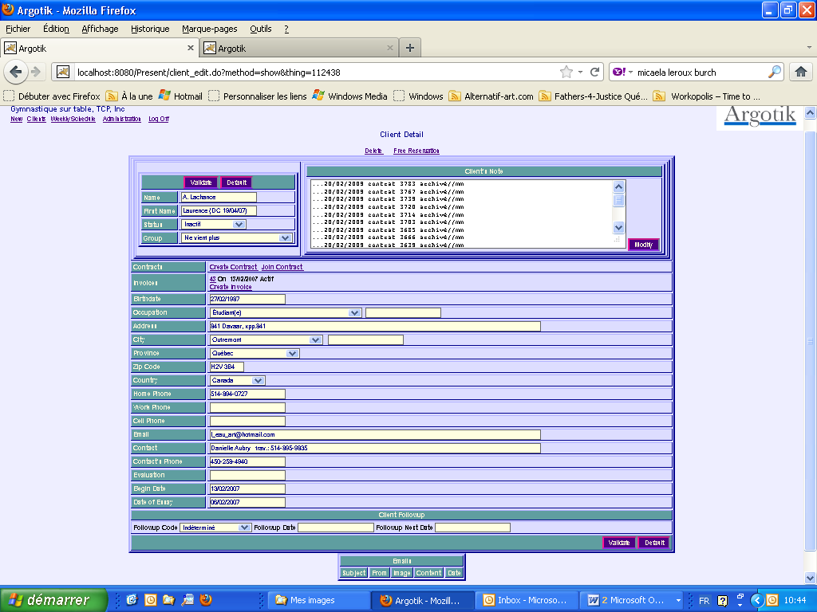

Delete

This is used to remove the shown client. When clicked, a pop up window ask for confirmation to avoid deleting the client. If confirm the deleting, the client, all its contracts, invoice and reservation will be removed. For convenient usage, all the deleted data are copied to a paralleled archive database (not accessible through the application yet).

Free Reservation

When a client is invited to a free introduction course for an essay, it is convenient to set a free reservation (out of an Invoice or a Contract). These kind of reservation will show up in the course Presence Sheet but without the possibility to set them present or absent and will not be counted in financial reports. If one goes there, the client status will automatically be reset to Invited. A special sceen to set up the reservation will appears.

Validate button

This button is to save the data in the database. The same button is also displayed at the bottom of the screen.

Default button

This button is used to reset the data to its original state.

Name and First Name

Without comment.

Status

The status is the actual Client’s Status for that client. The status could be redefined in the Administration/Business Logic module. See the Business Logic section for detail about this feature. Some action will modify the Client Status automatically like when a Contract is created for a client, its status should become Regular. When the contract ends the client status becomes Inactive. The client statuses are used throughout the application to restrict lists of clients based on their status, like in the Presence Sheet.

Group

The client could be assigned to a group. The groups are defined in the Administration/Statics List module. The Groups are used to discriminate clients based on their groups especially through the reports and financial reports. A client can belong to only one group at a time.

Client's Note

This is where one can put any information about the follow up of the client. The Modify button is to save the content of the note separately from the Client data. This same note is also available through the Client’s Presence Card along with the Contract’s Note.

Contracts

This section will show the list of contracts for that client (if there is any). Each contract displays one line as follow:

HTU3569UTH 1 cours E from 13/02/2007 to 13/02/2007 Ended HTUPresence Card UTH

The contract number (clickable to access the Contract screen)
The contract type (see Administration/Contracts)
The beginning and end date of the contract
The contract status
A link to get to the Presence Card

Create Contract

This is a link to create a new contract for that client.

Join Contract

This is a link to a special feature to join that client to the contract of another client. When used, it presents a list of contract to pick from and confirm that the actual client should be joined to the existing contract. One can join as many clients to a same contract this way. The list of all joined clients appears on the Presence Card and in the list of existing contract.

Invoices

This section will show the list of invoices for that client (if there is any). Each invoice displays one line as follow:

HTU300UTH On 14/12/2007 Active

The invoice number (clickable to access the Invoice screen)
The date
The invoice status

Create Invoice

This is a link to create a new invoice for that client.

Other Fields

In the other field to fill some shows a list of value to pick from like Occupation, City, State and Country. If the value is not in the list for the fields Occupation and City, enter the new value in the second field beside the list on the left of the row. This new value will be added to the list and assigned to that client when saving (Validate button clicked). Some fields require Date only, like Begin Date, Date of Essay, Evaluation and Birthdates (format MM/DD/YYYY. ex: 12/2/2001 or 1/30/2008).

That date format can vary depending on the Country where your business is active and the language you selected for your usage of Argotik (see section User’s List).

Client Followup

Here the client can be set in a followup campaign. See section Client Followup.

Emails

Here are listed the Emails the client received from Argotik. To send Emails to your clients with Argotik see the sections Clients List and Followup Alerts.

Client Contract

This screen shows the detail of a specific contract. Almost the same screen is used to create a new contract.

One can set up as many contacts as needed for the same customer.

Don’t hesitate to try and test, you can delete the contract if you wish upon error.

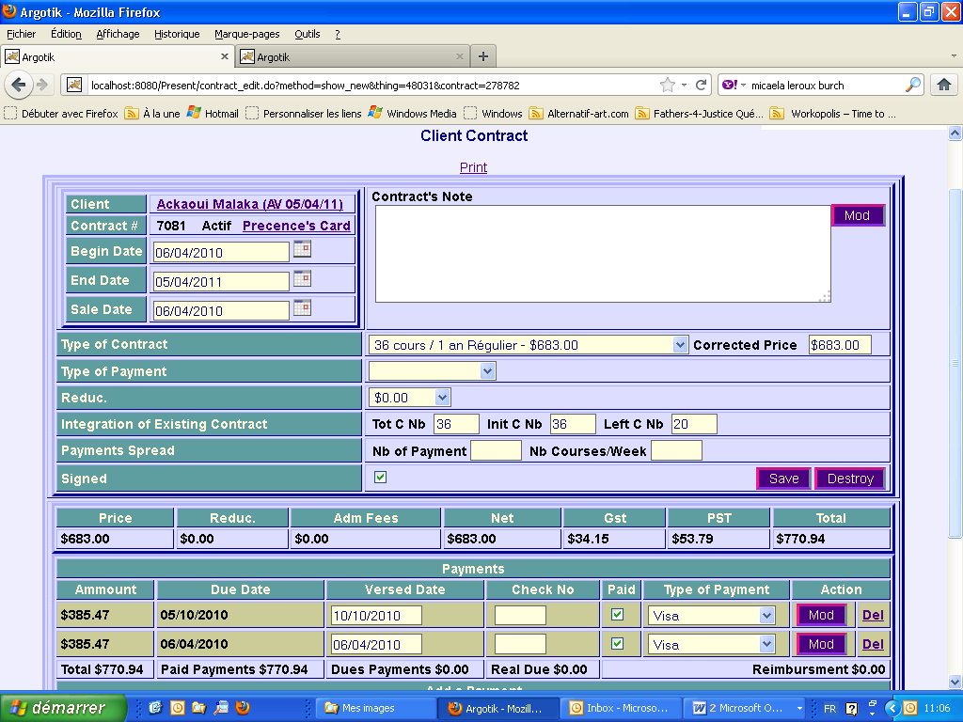

Print link: to print the contract. When clicked, a printing setup show up to select your printer. Each company has its specific look and feel for printing a contract. Ask technical support for a customization of your own company contract.

On the top left corner, client name is shown. It is follow by the contract number (an automatic unique number) the contract status and a link to the Presence Card for that contract. Finally the beginning, end and sale dates. The dates could be freely entered or selected through a calendar (by clicking the calendar icon).

On the top right corner, the contract note followed by a Mod button to modify only the note. The note is a place where to put all contract related information.

Type of Contract presents the selected type from a list of all available contract type (listed in Administration/Contracts). It shows both the Contract Type name and the associated price.

Corrected Price This is a place where one would change de default price for that contract, when needed for a specific contract. Otherwise it used the actual price from the contract definition.

Type of Payment Show the selected type of payment from the list of available type of payment (listed in Administration/Static List/Type of Payments)

Reduction This is the selected reduction allowed to that contract. It is picked from a list, the Reduction List (listed in Administration/Static List/Reduction). The reduction could be a specific amount ($9999.99) or a percent (99.99%).

Integration of Existing Contract There are three fields named Total Courses Number (Tot C Nb), Initial Course Number (Init C Nb) and Left Course Number (Left C Nb). This feature is mainly to show how many courses are left on how many. The Initial value could be set to less then the Total number of course when entering an already existing contract with used courses reservations one does not want to enter into the system. It will avoid to baldy affect the amount calculated for each course (see Administration/Finances). On a regular contract creation, one can left blank those three fields; they will be taking care of automatically on submission.

In doing so, if you do not wish to enter past reservations you proceed as follow:

In the Create Contract screen uses the 4P^{thP} line of the second block labeled Integration of Existing Contract

Paiments Spread A contract type definition already has a number of payments by default. The two fields Nb of Payments and Number of Course/week could be use to modify the default value so to spread the payments accordingly to the way the client will consume its contract. Upon submission of the contract, payments at specific dates will be calculated depending on the default value or the values entered in these fields. Payments could be added, deleted or modify freely then after.

Signed This box should be clicked when the contract is signed. It allows to prepare a contract and change it before it get into account by finance.

Save button Click that button to save the contract into the database.

Destroy button Click that button to destroy the contract. On click, it will show a confirm screen before deleting the contract. On deletion, all the associated reservations and payments will be deleted as well. Deletion is not a total loss because all deleted data is first store into a paralleled archive database. Archives are not available yet through any interface but this feature should come in the future.

Contract Amount Detail

The following line displays the detail of the contract amount, reduction, fees, taxes and total.

Payments

This bloc displays the payments list associated with that contract.

It is followed by a status of all payments. The Action column offers way to modify or delete the payments.

Add a Payment

If one needs to manually add a payment, this bloc is just for that.

Close the Contract

When needed, one can close and existing contract because the client did not come since too long or simply because she asked for it. To close a contract, fill the two fields Fees and closing Date before clicking on the Close button.

A confirmation screen shows up. Once confirmed, the contract appears again but with a status Closed and on a yellow background. A new bloc of closing information on white background is added. At the bottom of the screen, the closing form is replaced by a reopening contract link if need be.

Invoices

Use the Create Invoice link on the Client Detail screen to set a new invoice.

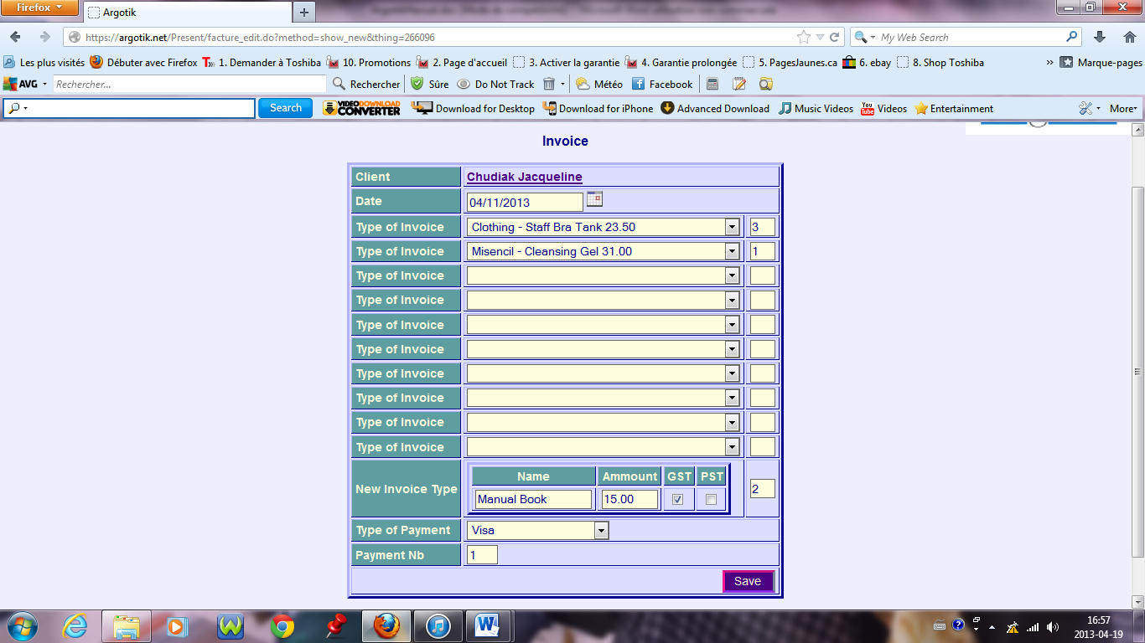

The date should be entered. One can choose up o ten predefined items and set the number for each. If an item does not exist yet in the system, use the New Invoice Item row to add the new one, alone with its price and checking when each tax applied. The new item would be available for any new invoice and also will appears in the Invoice Type (in Administration). Then set the payment method. If the Payment Nb is left blank, 1 payment is set… then click Save.

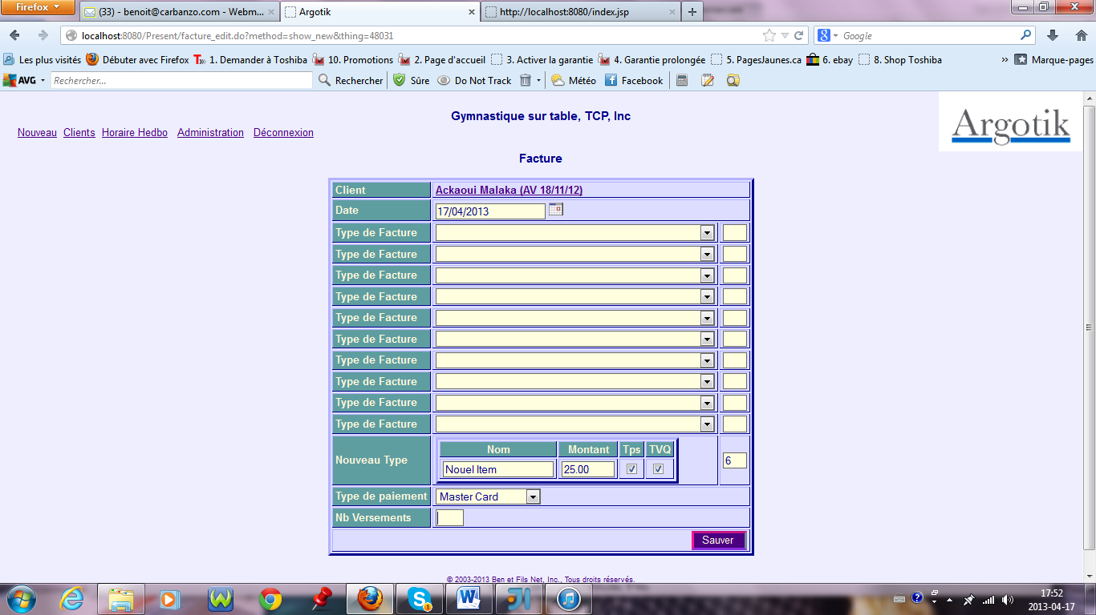

An already created invoice look a bit different.

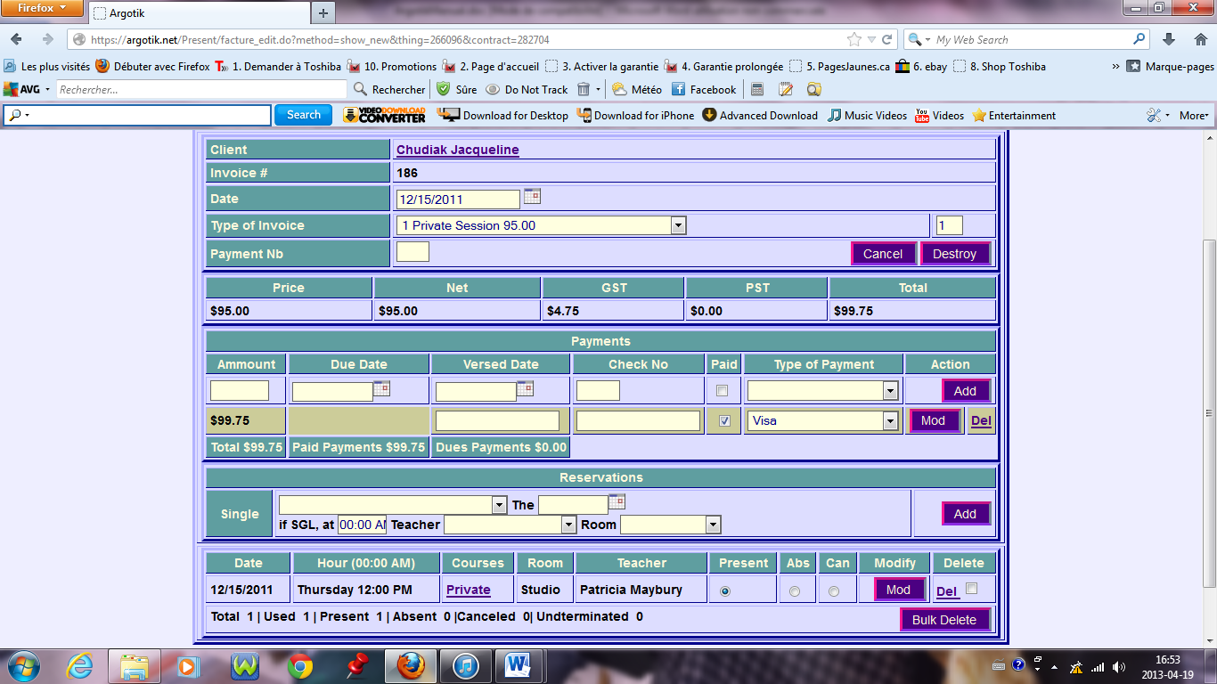

The invoice can be printed. Other then the items and the amounts, payments are listed (and can be changed). Also there is something like a mini Presence Card from which one can add reservation on sessions or private sessions.

Weekly Schedule by Location

This page is one of the most important one or at lest one that your users will use on a daily basis.

It displays the active schedule for a specific room from Monday to Sunday.

If the schedule does not display at first, one should select a Room from the central top bloc. Then the schedule will shows up. While moving through the application, your room selection and the specific week will be kept in memory (one can move in time using the Week and Month button). The specific week start date is displayed just beside the room select box. It is followed on the same line by a convenient quick link to reset the schedule to today’s week.

The hours list displayed on the first column correspond to the hours as in the existing courses (inside its own begin and end date) and rendezvous. Indeed, these two kind of elements (which shows as links) will lend one to the Presence Sheet (for a public course), and the other to the Client Presence Card (for a Rendezvous) or to and Invoice (when a rendezvous is set from an Invoice). Rendezvous will show up with the name of the client in a colored background for a quick reminder.

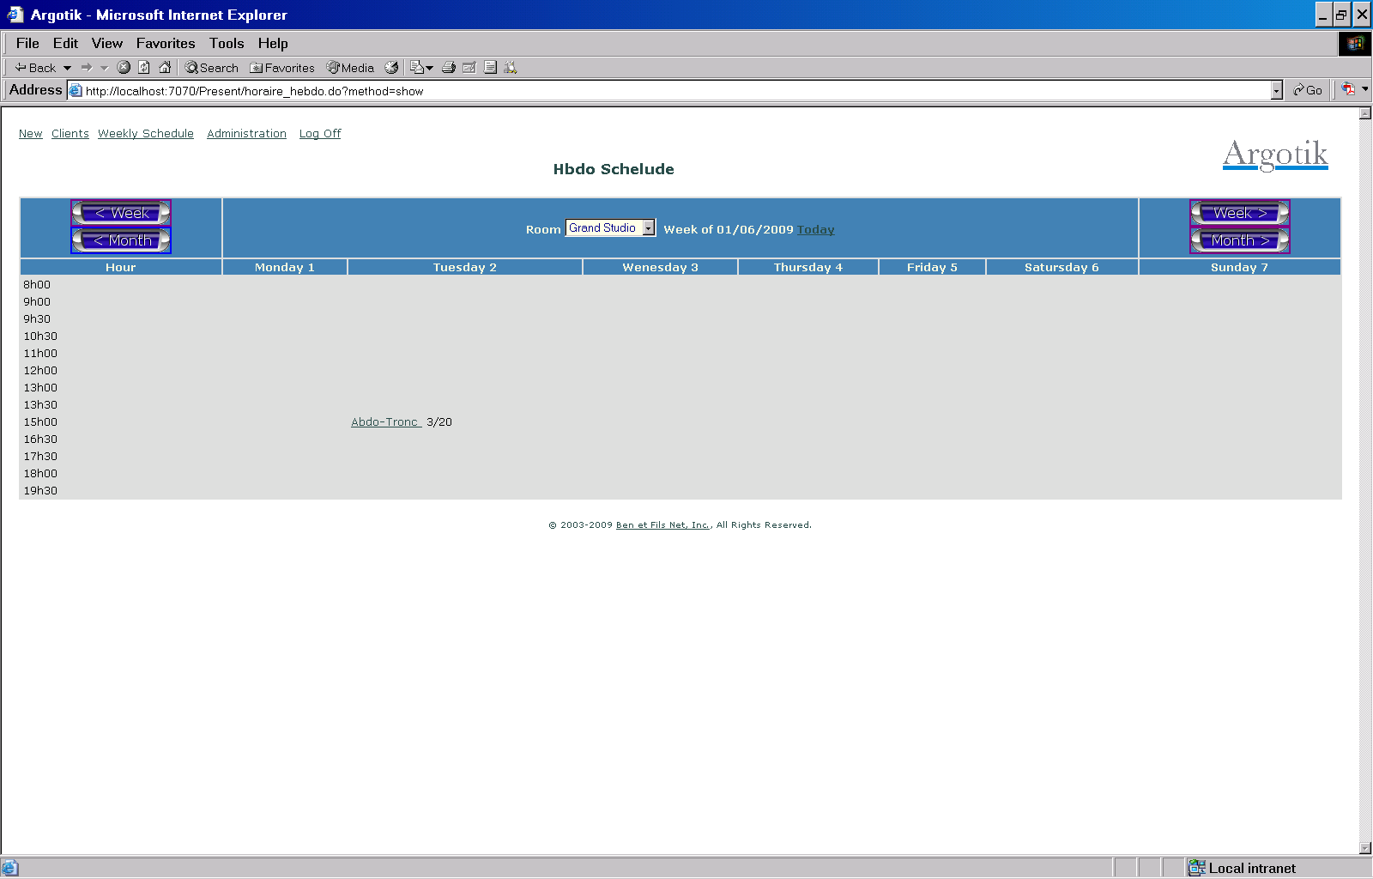

Presence Sheet

The Presence sheet shows the list of reservation for a specific course on a specific day. It allows the daily follow up of who is set to come to a course. Names of clients with other info (due payments) are listed.

The items shown are the Date, the Hour, the Course, the Teacher and the Room. Each Room has a specific number of places defined in the Room definition which limits the number of person in a course. When it become overcrowded, the follower will show up on gray background.

Reservations can be set to Present, Absent or Cancel. When Canceled, a reservation moves to the last bloc of the screen, canceled reservations. If a customer owes an amount (payment is past due) it is shown.

There are two lists from which one can pick up a name to add a reservation. The fist list contain customer with active contract (contract name with their ending date are shown as well). The second list contains all other customer. When one is picked, a dialog box appears to confirm the adding. If the client does not have a contract or an invoice and is not set as Invited the reservation could not be created.

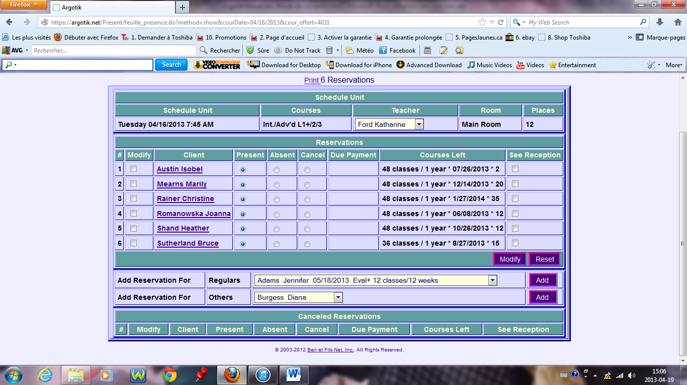

One can click on the name of the customer to access its Presence Sheet or its Invoice (depending if she has an active Contract or an Invoice).

Printing the Presence Sheet

The Presence Sheet can be print by clicking on the Print link. It is convenient to do so before a course for the customers to sign their presence.

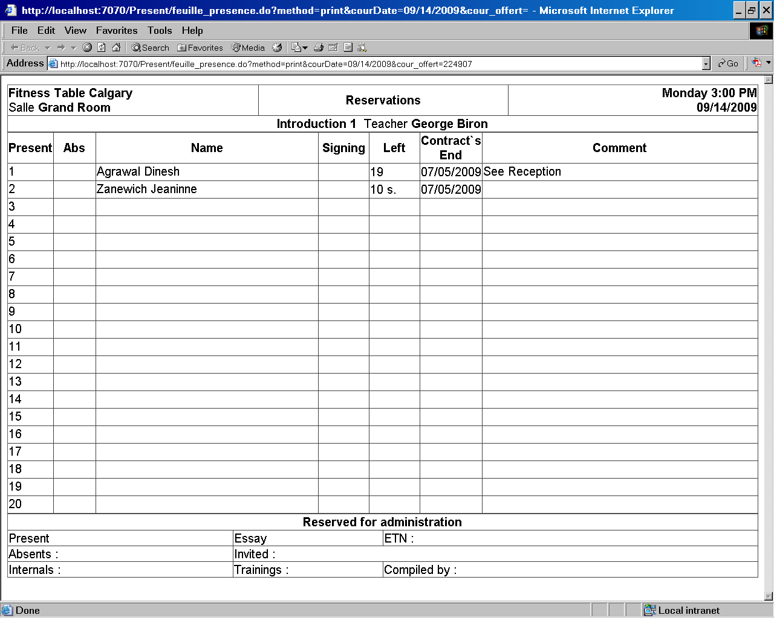

Once the course is done, one should set the presences for each person thus telling the software that these reservations were consumed (Present and Absent status does consume the reservations while Cancel does not. The counter for the number of courses followed through a contract is then updated as well as the number of remaining courses).

Each reservation is accessible as well through the Presence Card of each contract or Invoice. Their presence status could be set there as well as in the Presence Sheet.

The Presence Card

The Presence Card belongs to a contract. Its purpose is to follow the reservations of a customer through a specific signed contract.

The basic information: Customer name, Contract number, Contract Type, Beginning and Ending dates, Number of courses Attended and Left are shown on the top.

Then the Client Notes and the Contract Notes Blocs are seen and can be modified.

In the Add section, there are three ways to add reservation(s):

1- Recurrent

Choose a recurrent course and set the bound dates to add as many reservations (every week) at once.

2- Punctual

Choose a course and set the date of the specific reservation (The date and the course day in the week must fit otherwise an error message will appears after submitting the request.

3- As RDV (Rendez-vous)

Choose a Private type of course in the Punctual line along with the Date and add the Hour, the Room and the Teacher. These are specific for private courses.

When a contract gets consumed to its middle (half the reservation are consumed), the Presence Card background turn to light blue and then to pink when the contract is finish (all courses are consumed, notwithstanding the End Date of the contract).

The following bloc shows the list of reservations in chronological order. The Presence status can be set there as well as in the Presence Sheet. Use the Mod button to modify the corresponding reservation. Use de Del link to delete a reservation. Or use the check box to delete many reservations at once with the Bulk Delete button at the end of the reservations bloc. On that last line, a little report of the reservations is shown:

Total 6 | Used 5 | Present 2 | Absent 3 |Canceled 1| Undterminated 0

Lines in the reservation bloc are of alternate background color. To mark a specific row of reservation simply clicks on it anywhere to highlight it. Click again to come back to the regular background color.

The Reservation Bloc is followed by the same block showing the Payments as in the Contract Page. One can Modify and Delete payments here as well. Adding new payments is allowed at the end of that bloc.

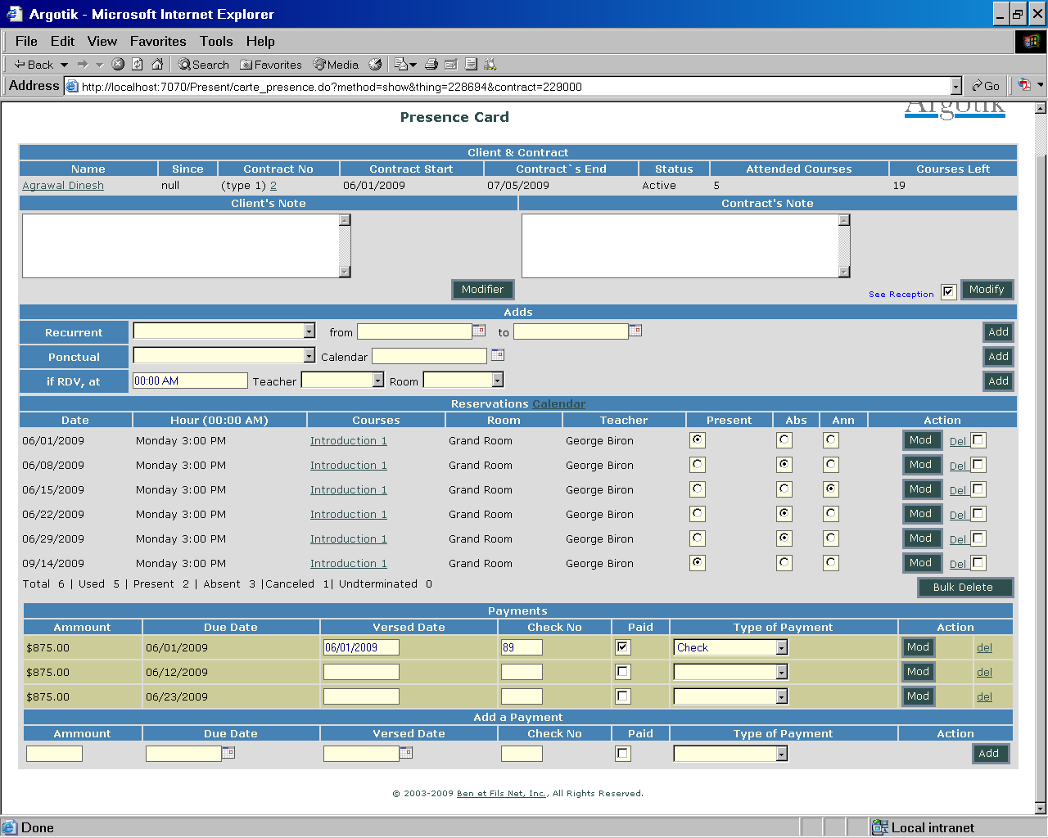

At the top of the Reservation List section there is a link to a Calendar of reservation to see the reservations in a Calendar form.

To be shown, at least one reservation must be already set. The reservation status shows Red for consumed (Present P or Absent A) and Blue when Cancelled X. A Green reservation is one that has no status yet R.

The Calendar starts in the week of the first reservation and stop showing reservation at the current week.

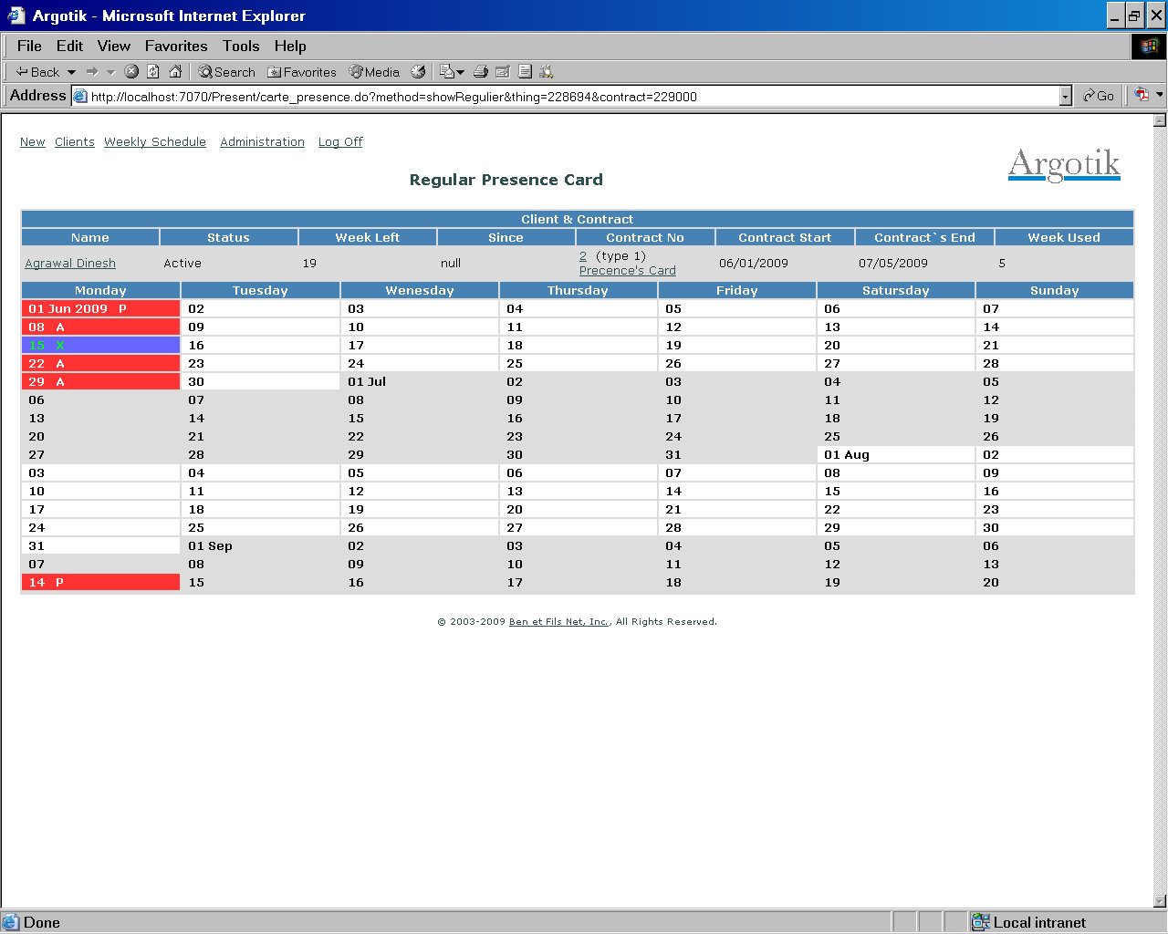

If the Contract is of unlimited type, the counter is based on Weeks consumed rather then on reservations. The Calendar is the place where to manually set if a week was consumed by clicking the check box.

Administration

The Administration section shows a list of links to administrative features. It is split in tow parts, the uppermost for definitions and the lower part for reports and configurations.

The Administration page is no available to User type of users (See User`s List) but only for Supervisor and Admin types of users. The Admin does not has access to the User`s List.

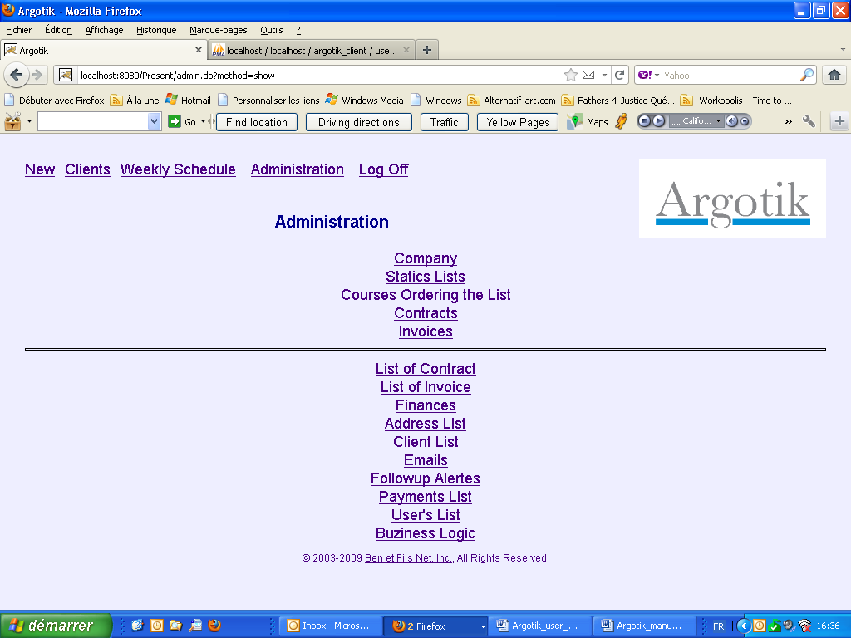

The features are

Company

Company name and address, taxes number and other details that appears in print out of Contracts, Invoices and Presence Sheet.

Static Lists

Static lists are list of fixes named values that could show up in the application to pick up from.

An example of the screen for a static list shows on the first line a way to add a new element in the list. The following already existing elements can be modified (Mod) or retired (Del). They indeed are not really deleted because if some client, contracts or invoices relates to it they should still show up. But once retired the element will not show up in list where to use it for new contract, client and invoice.

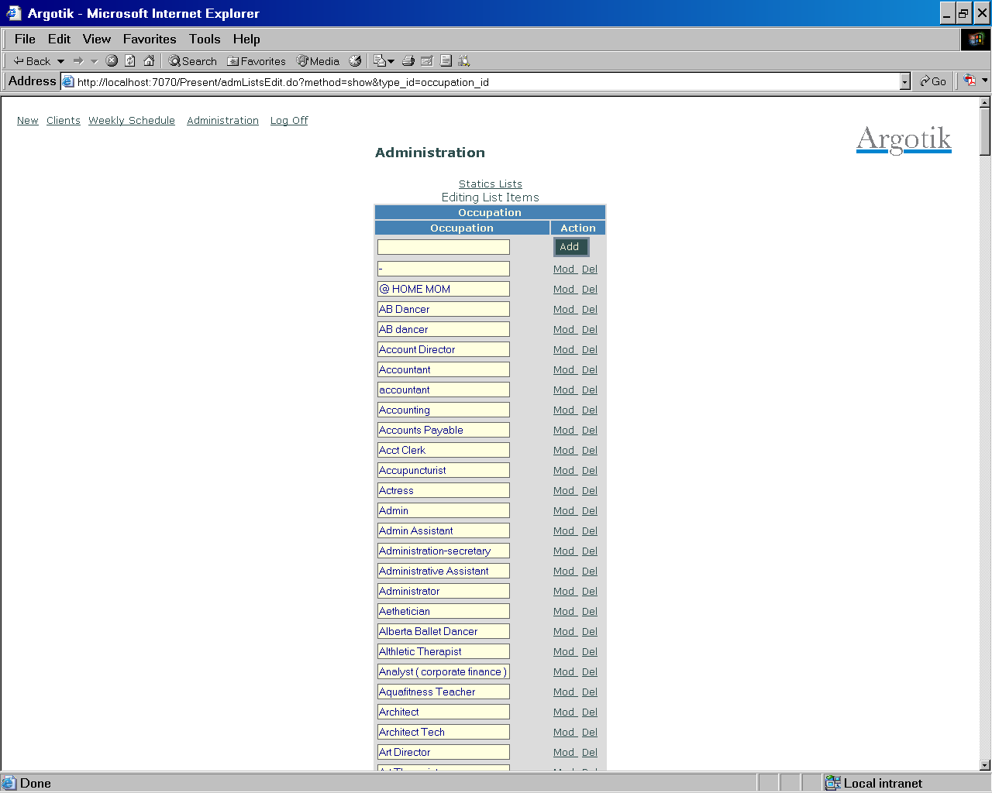

The lists of static elements are

Clients Group

A way to distinguish between different type of client (a client can only belong to one group at a time.

Occupations

Client occupation as work

Cities

The list of cities. Both Occupations and Cities can be dynamically added when creating a new client.

Provinces

Countries

Payments Types

Reductions

These are reduction that can be applied onto Contract and Invoice. It can have two form an amount ($9999.99) or a percent (99.99%). The reduction is applied to a price before taxes.

Teachers

Rooms

Rooms have a number of places (maximum number of person that can attend a course in the room). This number is overwritten by the number of person defined in a course definition when the course happens in that room.

Taxes

Unlike other static lists, the taxes are unique (only one line), one for the federal and one for provincial taxes.

Taxes : You can have more then one tax set in memory, but only one can be activated at a time. The tax name should reflect a Java object definition into the code (Quebec2013, Quebec2012, BritishColumbia2012 et BritishColumbia2013). All other tax name would refer to the default tax definition. Each Java tax definition contains its own taxe calculation method which is based on the province rules. The taxes are used when creating a contract or an invoice to calculate the amounts but then the amounts are saved into the each contract and invoices and not affected by changes in taxes definition.

The amounts of HST and PST should be provides in percent like 9.975 % (for 0.09975).

Other fields of the like formula don’t have usage still in Argotik.

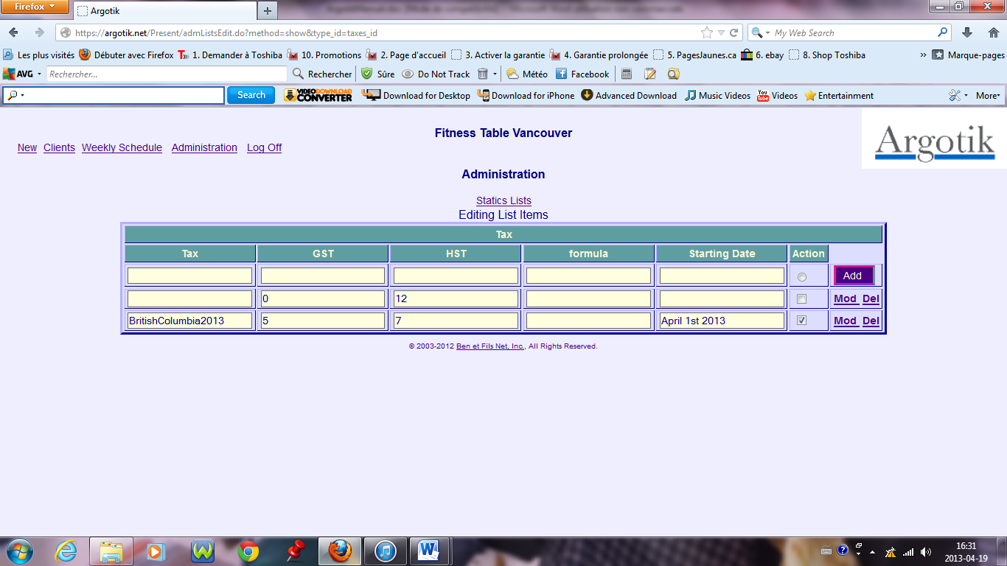

Courses

This screen is where to define the courses and set their weekly schedule.

Courses are only content definition while schedule units are weekly recurent event linking the course (what), the room (where), a teacher (who), a day and a beginning time (when). The Schedule unit is a recurent event.

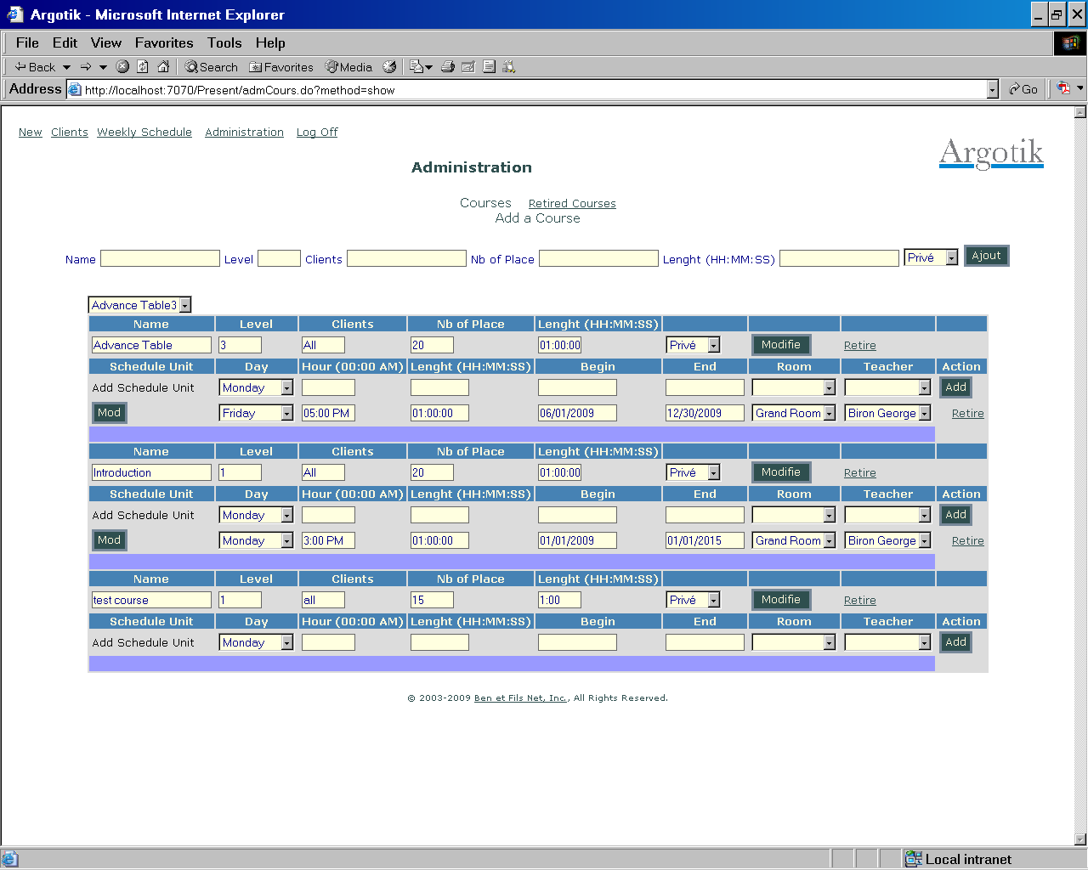

Add Courses

At the top there is a form to add new courses. The fields are

Name: the course name

Level: The level of a course (string or number)

Clients: Informative field about the target type of clients

Nb of Place: Maximum number of people how can attend the course at once. This value will overwrite the maximum number of people in a Room.

Lenght (HH:MM:SS) : Duration of the course in hours, minutes and second. Value as 2, 02 or 12:15 are allowed as well. This filed is not yet used but is planned to be use in the future. Actually, the weekly schedule takes into account the starting hour along with the day and date of a course.

Privé/Classe: This is the type of a course: Private or Class. Use Private to create a category of Private lesson. It should be use to set RDV (Rendez-vous) in Presence Card or Invoice with reservation. Rendez-vous will appear in the Weekly Schedule of the Room highlighted with the name of the client.

Prior to displaying the list of course, there is a convenient drop down list to jump directly to the selected course. When one have many courses, its help to get directly to the right one without having to search for it in a huge list.

Courses Edition

The list is organized by blocs each one of them showing three parts: first the course definition (as entered using the topmost form described here before); second a form to add new Schedule Unit for that specific course; third the list of Schedule units for that course.

The course definition could be edited and modified directly using the Modify button. This button is followed by a Retired link to retire a course. Retiring a course makes it unavailable to the Weekly Schedule but still visible for old reservations through the Presence Card related to contracts or Invoice. On retiring a course definition, all Unit Schedule associated will be retire along with the course.

Schedule Units (Event)

The second part of the bloc is where to ass a Schedule Unit. A Schedule Unit has the following fields:

Day: Day in a week

Hour (00:00 AM): This is when the course start. Value could be as 1 AM, 3:15 PM, 03:25 PM. The space between the hour and AM or PM is mandatory as well as the AM or PM.

Length: Time duration for the course (for future feature, not yet used)

Begin: The Date when the schedule unit starts.

End: The Date when that schedule unit stops. Outer of these bounds, the schedule units are not visible on the Weekly Schedule and no reservation can be set to that schedule unit out of these Dates boundary. It is important to know it especially when creating Recurent reservation in the Presence Card. Reservation will not be created for a Schedule Unit outside of the boundary Dates.

Room: The room where the schedule unit will be given.

Teacher: The default teacher for that schedule unit. The teacher could be change for another on a specific day only for printing of the Presence Sheet (see Presence Sheet).

Then there is the Add button at the end of the line.

The following lines are the many already existing schedule unit for the same course definition. It is preceded with its Modify button and ended with its Retire link. To access the retired Courses and Schedule Unit, follow the link «Retired Courses» at the top of the page.

Each schedule unit can be retired using a link at the end of the respecting row. Retiring a schedule unit makes it disappears form the schedule and from the list of courses. When calling the Retiring of a schedule unit, first a confirmation screen with warning appears. Then a list of reservation associated to the schedule unit. The same happen when one want to change the time or day requesting to move the reservation along with the unit. Be careful when doing such a move to make sure its reflect you needs. Once done a retired schedule unit could only be set back by and administrator of your Argotik hosting provider.

Retired Courses

This screen shows not only the retired courses but all the courses, retired or not. It does not show the «Add Courses» form nor the «Add Schedule Unit» forms.

The already retired courses are on red background and the active courses on light background. From there one can destroy retired courses. If this is done, a confirmation box will show up to confirm the deletion.

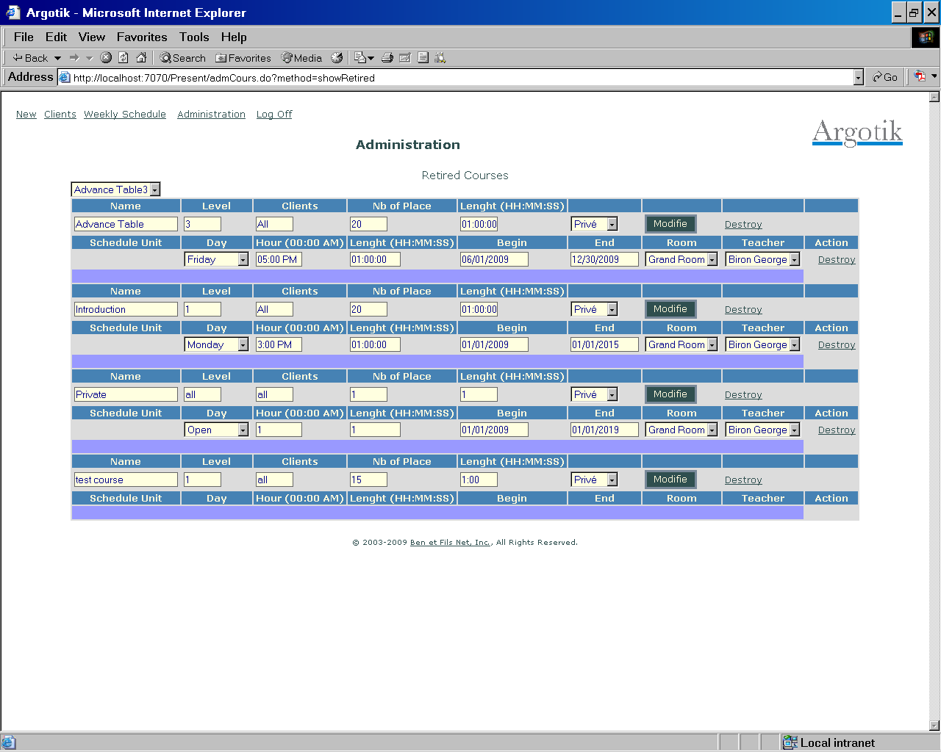

Ordering the List

This is a place where to set in order the list of courses as they should appears when one add a reservation. The numbers does not have to fallow each other as soon as they are greater or lesser the others. It is suggested to order the courses chronologically of easy retrieval into the lists. One can proceed y using the numbers from 1 to 20 for the Mondays, 21 to 40 for Tuesday an so on. Once save, you can refine the order inside a day using the hours as a scale. All is saved at once clicking the Change button.

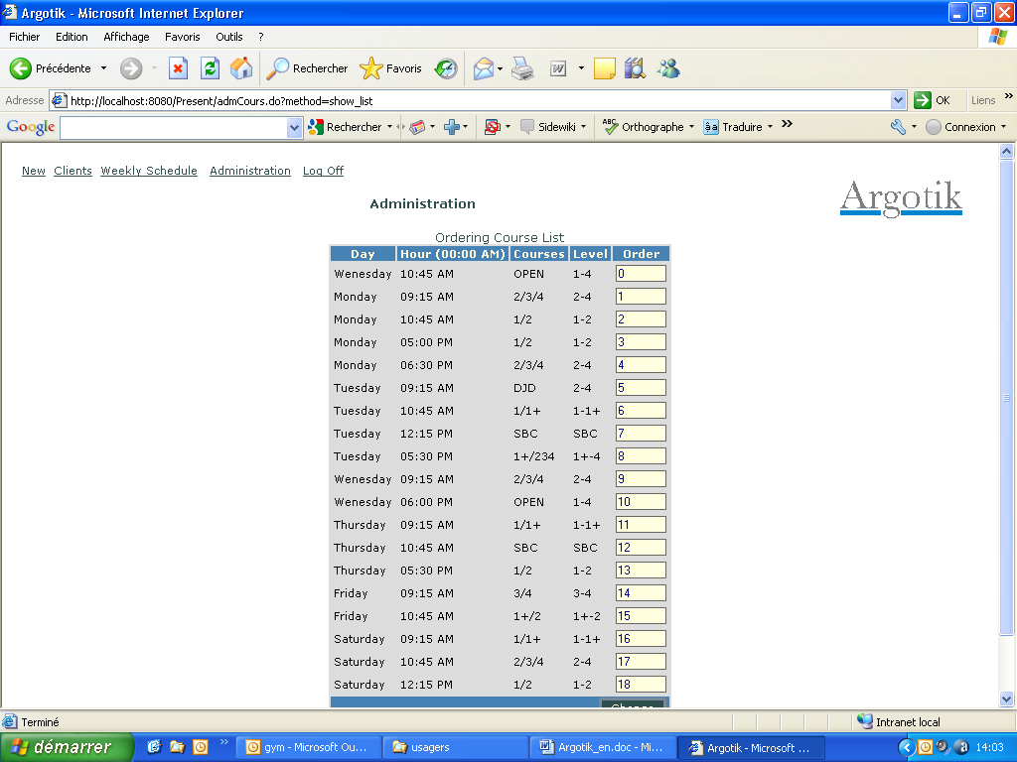

Contracts

Where are defined the types of contracts. The first line in the table, after the column labels is where one can add a new contract type. The fields go as follows:

Name | (Weeks) | Year | Ammount | Payment Nb | Courses Nb | Type of Course | Action

Name: The name of the contract type

(Weeks): The number of weeks spent. If the contract is Unlimited (type of course is set herein) the number of weeks will be used as a counter to decrement down. If the contract is of regular type, the number of weeks is only for information.

Take notice that for financial reports, The total amount of the contract is divides by the number of weeks used (consumed) to calculate the Real Income and the Income Perceived in Advance (see these topic)

Year: This in informative only, Note the year the contract is created.

Amount: The basic cost of the contract. This will appear in the contract form where it could be change on the fly or add a reduction. The amount will also appears in the list of contracts.

Payment Nb: By default Number of payments for that contract type. This number could e change on the fly when creating a contract. (see create contract)

Type of Course: You have two choices: Regular and Unlimited. In Regular mode, each course count for one unit while in unlimited mode, each week spent count for one unit. The way presences are taking is different (see presence card).

Action: For adding a new contract type the button Add effectively does it.
For modifying an existing contract type, click on Mod. When changing a contract type take care to keep the same Type of Course or simply add a new contract type rather.
To retire a contrat type use the link Retire of the corresponding row.

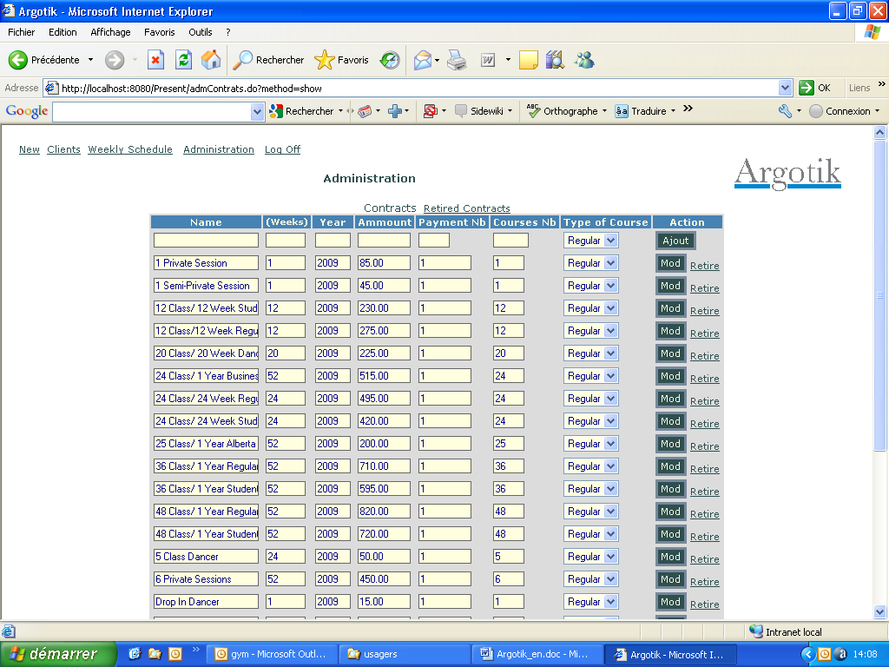

Invoices

For Invoice types, it goes similarly as contract type except that there is fewer columns to define. GST and PST check box are to be set when federal or provincial taxes do apply to each invoice type.

The difference between Invoice and contract is that in one invoice you can put up to 10 items (Invoice Type) and each with as many unit of each items. Invoice has its module to set reservation as well as contracts (through the presence card) but finance report will not take count of the consumed courses for Invoices as it does for contracts. For invoices, only payments will be taken into account.

The first line under the columns labels is for to add a new Invoice type.

There is no possibility to change an Invoice type. If change is needed, creates a new Invoice type and Retired the old version of it.

The changes made here as well as in the contract type should appears immediately throughout the application.

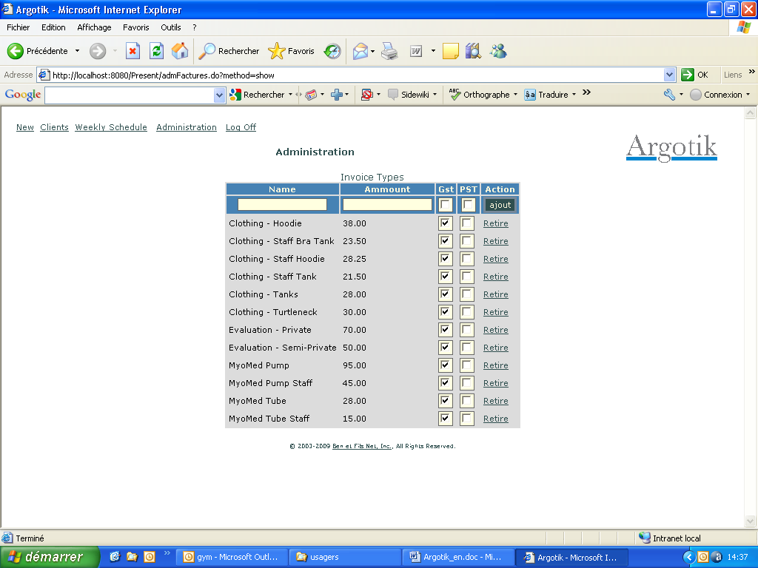

On the Administration page, let now look at the lowest part (Links under the horizontal rule) which is about reports and configuration.

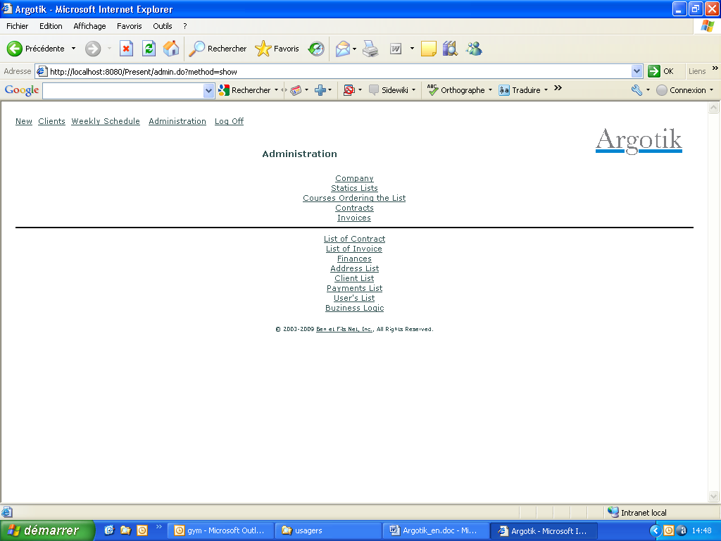

List of Contracts

The first screen is a combo of many search options to provide a flexible list of real contracts.

The simplest way to show up all the contracts (if these is not too much of them) is to left all search criteria blank and click on the List button.

Otherwise one can enter a value into one of the criteria to get all what look like the criteria entered. For example, if G in entered into the Name criteria all contract for clients whose names contains the letter g will be retrieved. This goes for First Name, Phone, Zip Code and Contract No.

Some criteria are shows a list. It is the case for City, Type of Contract, Client Status, Contract Status and Group. Only one value of each can be selected for a single search.

There is a serie of criteria that are of Date type. Those shows two limits in time for the beginning and the end. One can enter only one of them or both to sets limits on the beginning or the end or both.

There is a special Last Presence on Active Contract check box with the option to retrieve those contracts where the client does not come anymore. This is convenient to make a follow up on these clients that did not come sine a while or to close their contract. This criterion excludes all other criteria set in the form. It is followed by three radio boxes to select the first 100, the following 100 or the last 100 of them. There could be more but they are not retrievable.

Although the order in the list is based on Last Name and First Name, one can set another order using the Ordered By and 2P^{ndP} Order drop down list of option.

The last two lines of the criteria panel shows three check box to set which extra columns one would like to see in the list. Price to show the amounts data, Used to show the numbers of courses used and Dates to show the dates of the contracts. All could e set at once using the All link or none using the None link on the last line.

The List button launches the search and show the resulted list.
The Default button is for resetting the criteria’s as it were when the page showed up.

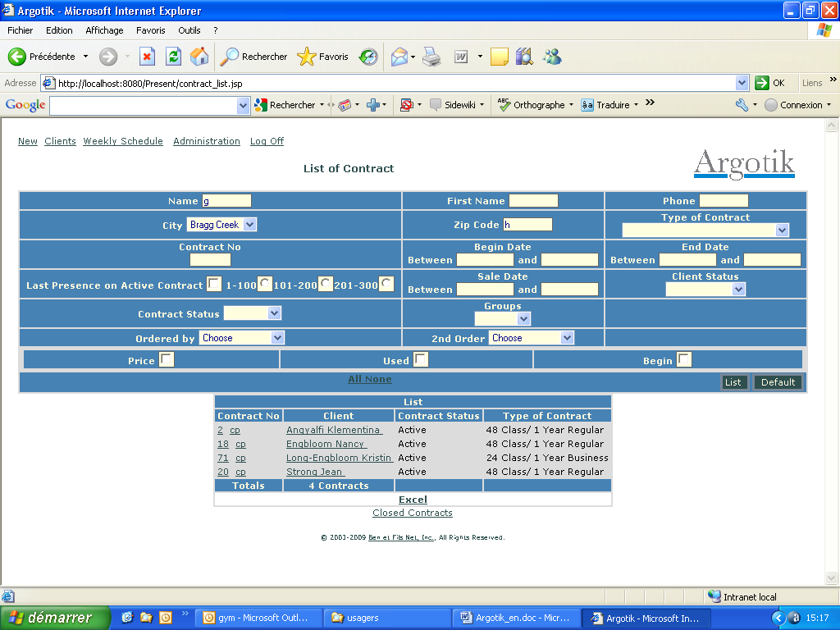

Once the list shows up the criteria’s options are kept.

The list itself, by default shows the contract number (clickable to go to that contract page) and a cp link to go directly to the Presence Card of that contract. The client name is also clickable to get to the Client definition.

The last line of the whole list provides additional data as the sums of all the amounts for money columns. It shows as well the number of listed contracts.

After the listed table, there is a Excel link to extract an Excel Spread Sheet of the repport in another window. Once clicked, the Excel link disappears to remove the huge amount of data that this feature could generate in your session and free the memory resources.

Finally, the Closed Contract link we bring you to a list of closed contracts following the same criteria.

List of Invoice

It is pretty much the same as Contract List. It has as set of criteria to retrieve a restrictive list of Invoice. Last line show total amount of what is displayed in the list.

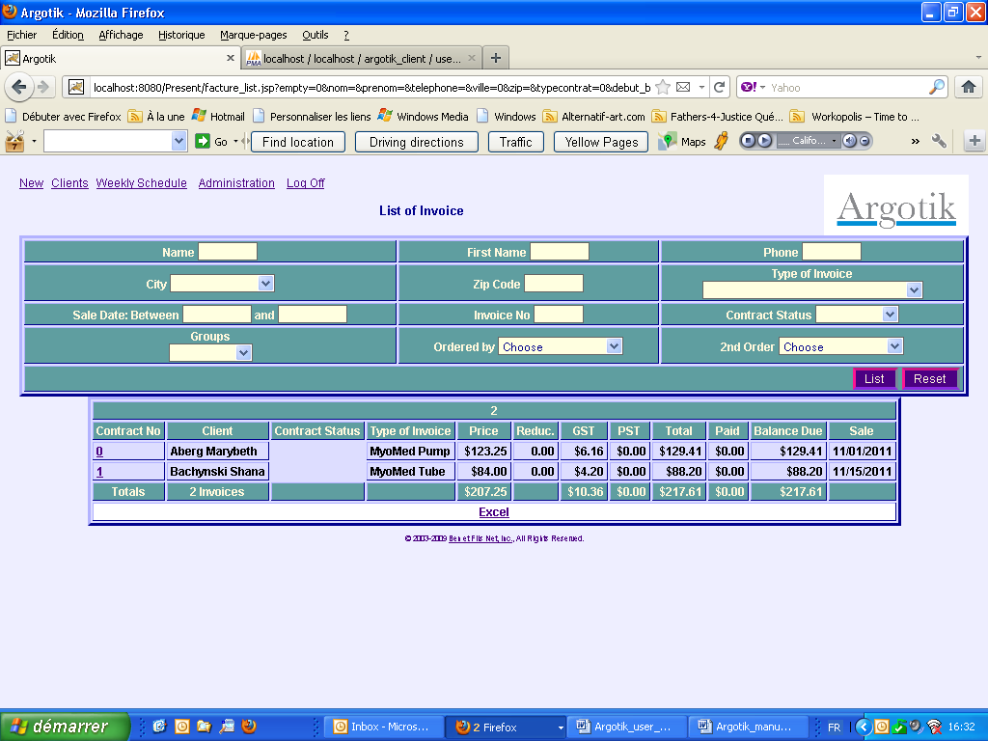

Finances

The finances screen shows two features to produce financial reports:

Real Income (RI)

Income Perceived in Advance (IPA)

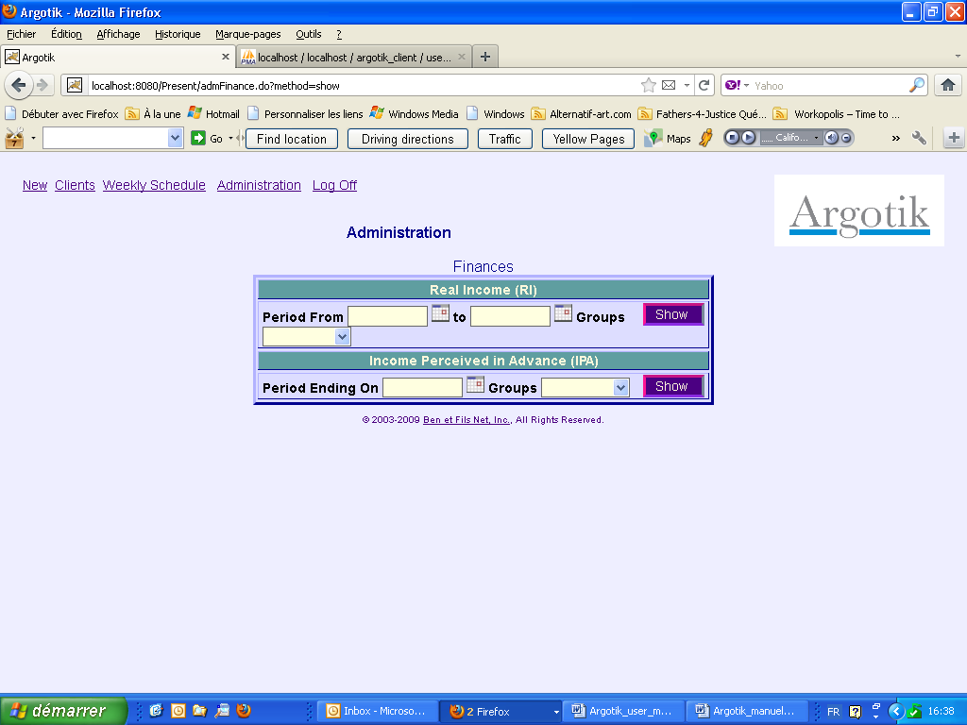

Real Income

Real Income (RI) required two boundary dates: from and to. One can also select a group in the list to limits the report to a specific group of client. Clicking the submit button provides the report in three main block:

Regular Contracts
Unlimited Contracts
Closed Contracts

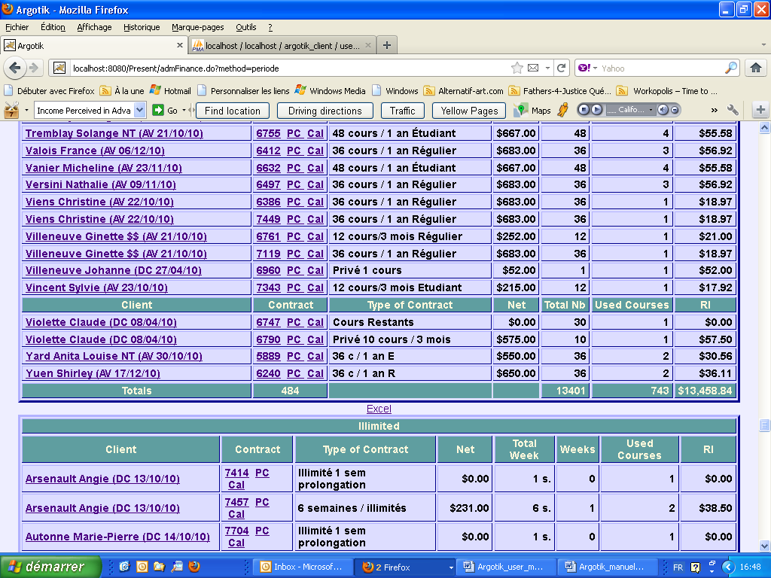

Each block has its end line providing the Total Sum of the respective column (number of contracts, number of events and the total amount of money cashed as real income. Only Present and Absent Status on events in each contract are calculated.

Each block is followed by a Link to exporting to Excel Spreadsheet (xls format, Excel inside the browser). Once the Excel link is used, it disappears while the memory used to keep the data is flushed. To get it back, one needs to call the report again.

Normal usage of this type of report is on a monthly basis. Calling a report for a whole year may be long to calculate and show up depending of the scale of the activity of the company.

Notice that the status of a reservation does not keep track of what it was at a certain date in the past. It always shows its actual value. Although, when one ask for report with a end date, only the reservations inside the time frame will be taken into account.

Income perceived in advance (IPA)

This report looks almost the same as the previous but it takes only a end date as criteria (with User Group, optional).

The content of that report gives the amounts on each contrast that are not yet consumed. Amounts are based on the value of the contract minus the reservations consumed. Totals are shown at the end of each block (regular contract, unlimited contract).

Extraction to Excel spreadsheet is available for each block.

Address List

The address list show few criteria to refine the list of customer addresses to be retrieve. One can left all criteria blank to get the full list of customer addresses.

The result is sent as a downloaded Excel Spreadsheet file to save on your local disk or to open. This feature is meant to help create addresses sticker for bulk mailing. In addition to addresses, phone numbers are displayed as well

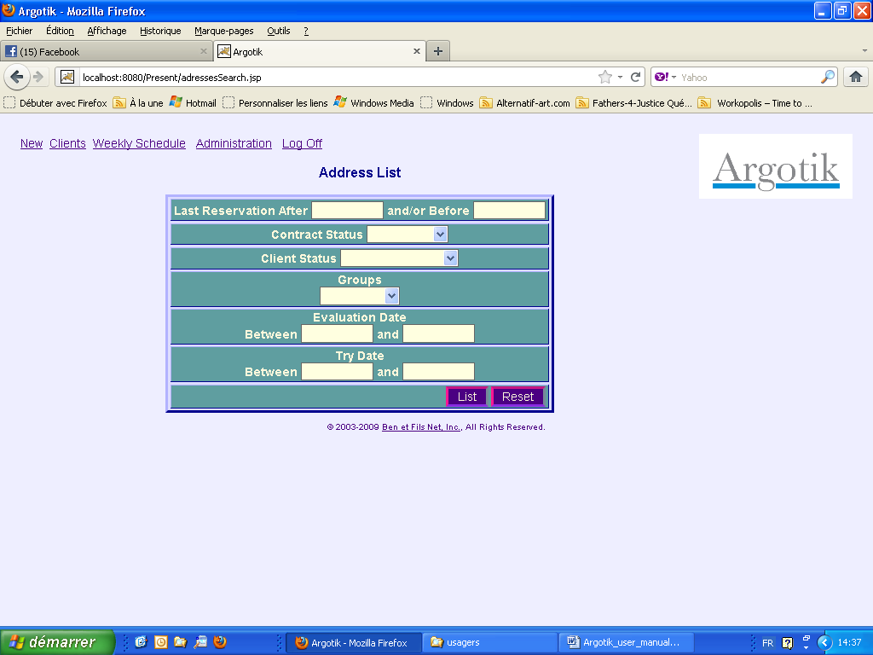

Client List

Again, a list of criteria to limit the list of client to retrieve is first shown. The criterias will add one to another to limit the result of the list.

Name, First Name, Phone and Zip code could accept only one character and will retrieve all records containing that letter (not only the records starting with this character).

Date fields could use none, one or both of begin or end date.

City, Type of Contract, Client Status, Contract Status and Groups are lists of all existing values of each of those fields.

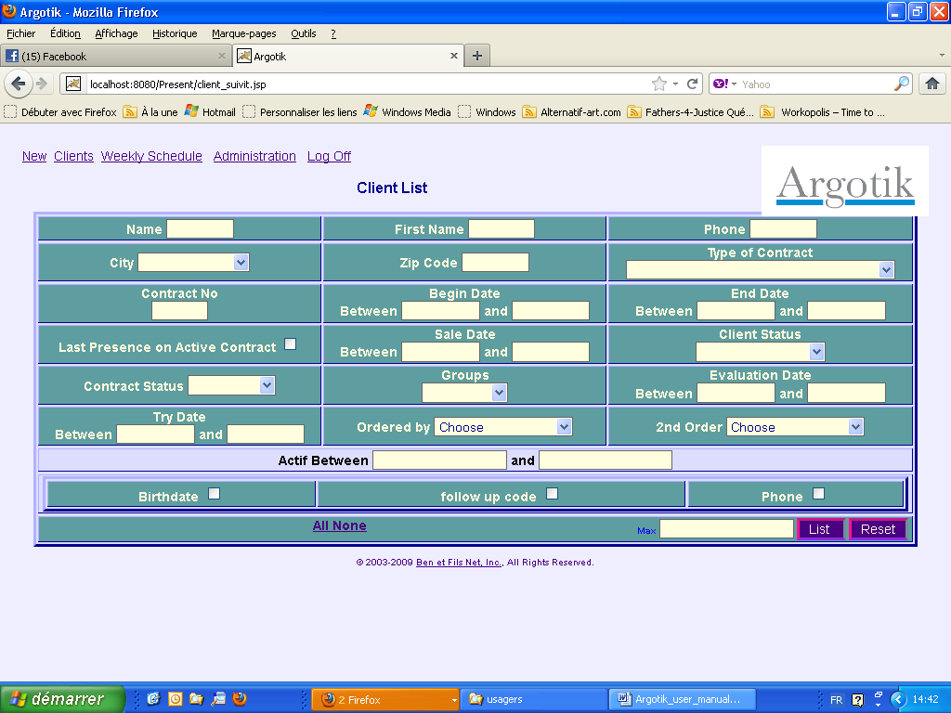

Last Presence on Active Contract check box will bypass all other criteria to retrieves a list of 100 customer who are not attending since a while (starting with the oldest last presence). This feature helps you to identify your customer that does not come anymore, either to contact then or to close their contract.

The criteria are kept into memory and shows again once the list is called.

There are two ordering fields available.

Three check box allow to show more fields in the report:
Birthdate : Dates
Follow up Code: Follow up Code, Last follow up date and Next Step date
Phone: Phone numbers and email addresses

The report allows creating, testing and sending emails to the selected customers from the list.

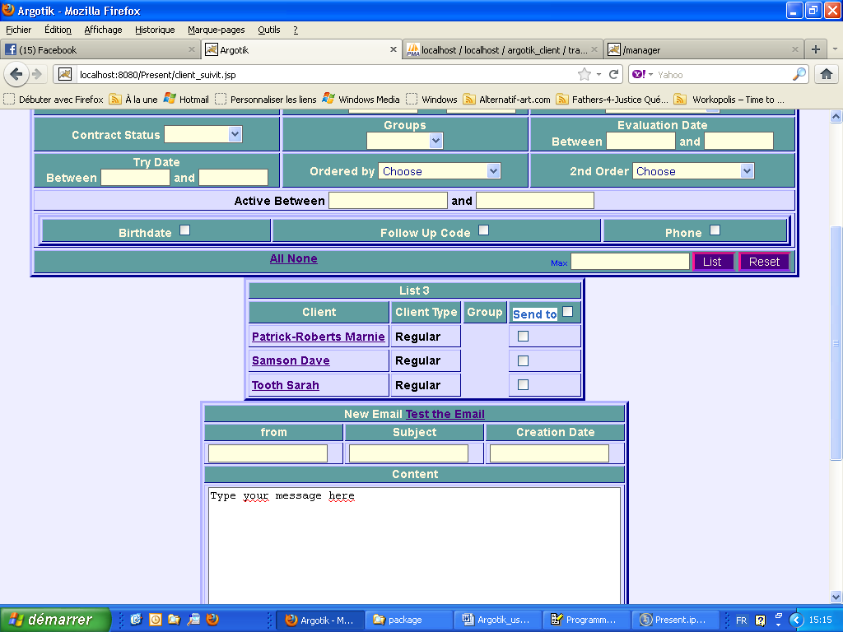

The Send To check box checks all the clients in the list as targets to the email. Checking the box again uncheck them all. Only client with a valid Email Address will be sent Email.

Using the New Email box allows to compose an Email. Fill the From (From which Email Address the Email is sent), Subject and Creation Date (Month/Date/Year ie 12/01/2011). Fill the Content with your message. You can use all HTML tag to creates nice layout and links, etc. Then click Test the Email to send the Email to the From Email address to check the result before sending the Email to every one. Goes to the From Email Address mail box to see if you got the Email and verify the look and fell and the way your customers will see it.

Once you are sure about the end result, use the Back Button of your Browser to retrieve the content of your just created Email, make sure the selection of customer is right (the check box of each customer in the last field of the client list) then click the Send button at the bottom of the Content Box.

Each Email is kept into the database. See the following section to know more about it.

Emails

The Emails link in the Administration Page leads to a list of Email that had been sent through the Client List Email sending feature. The Subject field is a link to the detail of each of them.

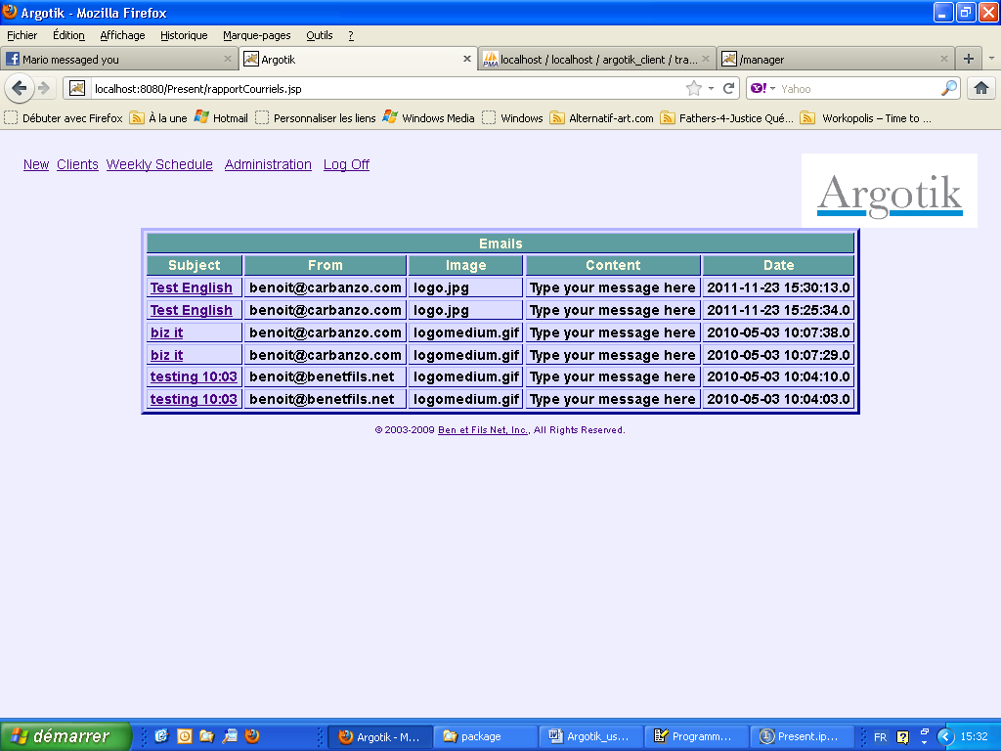

The following screen shows the detail of that specific Email with:

The Subject
The date
The From Email Address
The Logo
The text content
The List to each client to which the Email was sent.

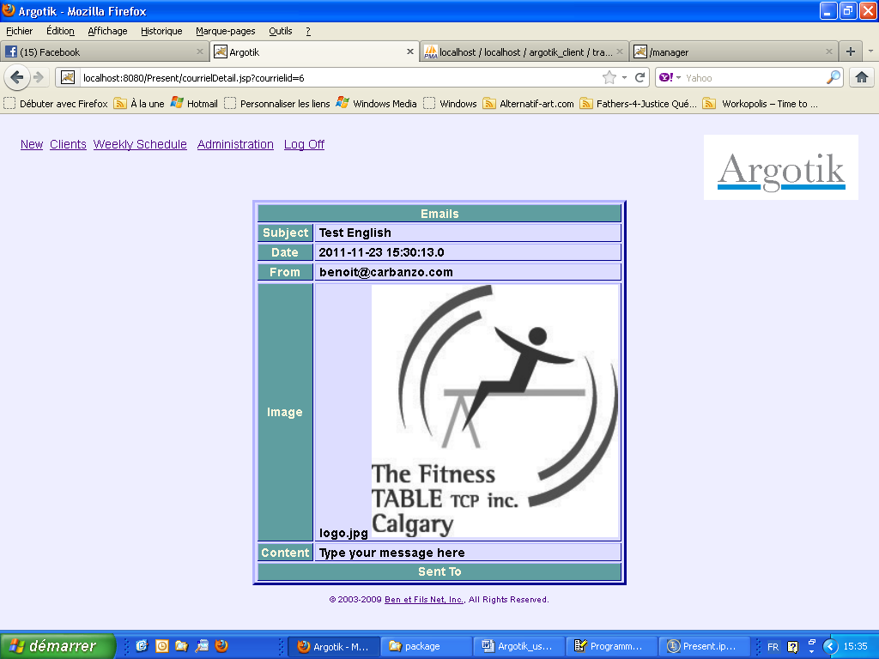

Up to now, the logo and its size could not be change unless a specific demand to the administrator of your Argotik Application Hosting.

The Emails are also listed on each Client page (at the bottom) to which it had been sent.

Follow up Alerts

This feature allows following up clients communications in marketing campaign. .

To set up Client Follow ups, an Administrator should first creates a Followup Code :

Go to Administration
Go to Business Logic
Use the Add Status, select the Client Followup Type and enter a sound name reflecting the way you want to follow your client. You can add as much Followup Code as needed.

The created Followup Code shows up in the second block under the Type Followup Code and are available in the Client Page to assign to a client. One can modify a Followup code in the same block. Followup Code cannot be deleted as well as any other Status, while this could disrupt the application where some data can still be pointing to old Status.

Then go to a Client page (last block before Emails) and set the follow up code, the last Followup Date and the Next Followup Date.and clck the Validate button to save it.

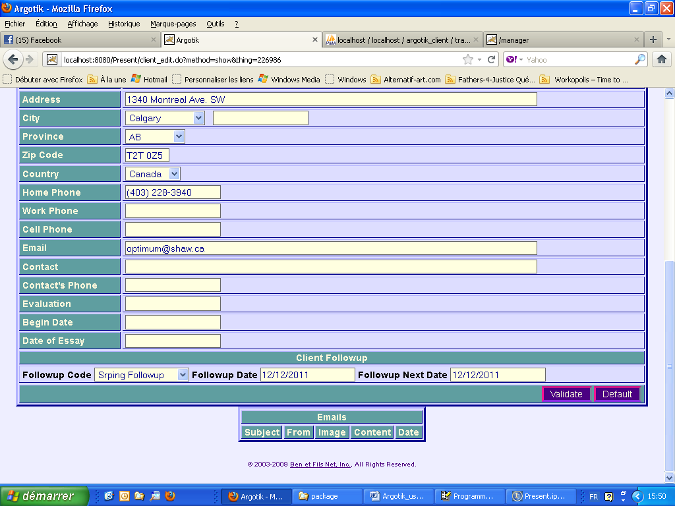

Then when one goes to the Followup Alertes Page, the Client will show in the List.

There are the same feature to send Email as in the Client list, the Email are recorded, etc.

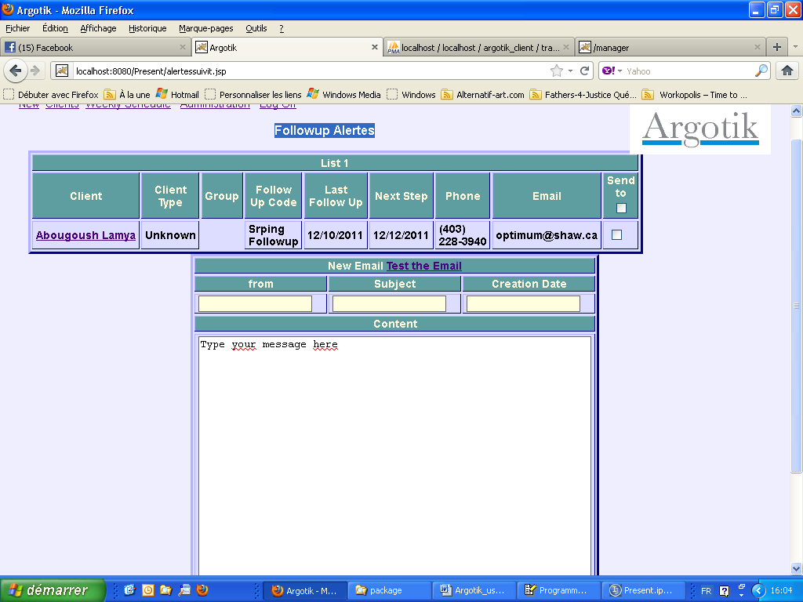

Payments List

This is another report to see the client’s payments on their contracts and invoices.

As previous reports, a list of criteria are available to restrict the content of the list. At the end of the list two Total are provides on both the Dues and Paid payments.

An Excel spreadsheet like is provided to export the data.

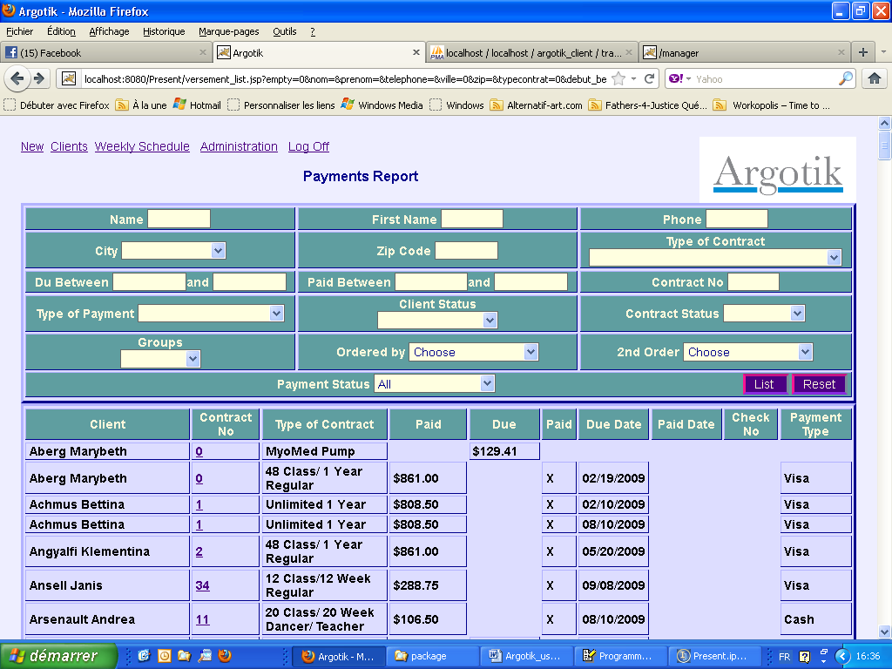

User's List

This link in Administration lend to a few features to manage the Argotik Users :

Add User

To add a new user to Argotik enter the user ID, the user password and the Role of that user:

Supervisor: Access to every feature in Argotik

Administrator: Access to everything except this very module (User’List)

User: Access to everything except the whole feature under the Administation link.

User Modification

It shows the list of active users. There one can change the user ID, password and the Role to which this user belong.

Style Modification

This is a way to change the look and feel of the Argotik application for your company. Try the three available look and fix your choice on the best look that fits your taste.

Configuration

There you can modify the language, the Country and the Timezone to which fits and please you the best. There are only two languages available now, French and English. Only two countries, US and CA and only one Timezone. To get more, ask you Argotik hosting administrator.

Once a change is made in that block, you will be automatically log out for Argotik to allow the change to take place. Once logged in, the change should be reflected.

Business Logic

This feature is intended to help managing the behaviour of the whole Argotik for your business. There are three block in this screen: Behaviour of the application upon statuses is not automatic but is tied to the running programmed code underneath. One can change a Status.

Add Status

Status does apply to specific Type of data that are listed. Only Followup Status should be added here (see Alerts section)

Modify Status

One can modify the mane of a Status without affecting the behaviour of the application. This could be usefull to better reflect what its meant to you.

Automatic Status Modification

There are a few events on which the status will automaticly change:

On Contract Creation

The contract will be set to Active
The client will switch to Regular

On Contract End

The Contract will switch to Ended
The Client will switch to Standby (unless another active contract exist under its name)

On Contract Closing

The contract will switch to Closed
The Client will switch to Inactive (unless another open contract is under its name)

If you wish to modify these defaults behaviours, please talk with your Argotik Hosting administrator to help you envision the right way to do.

